***MA4605 Lecture 12 A Part 2 Computing Contrasts, Effects and Sum of Squares***

A factorial design is used to evaluate two or more factors simultaneously. The treatments are combinations of levels of the factors. Factorial designs are very efficient and they allow interactions to be detected, particularly where there is ***n*** replicates for each combination of factors.

We usually describe the levels as either low (-1) or high (+1) . Consider how this information is presented in the example below.

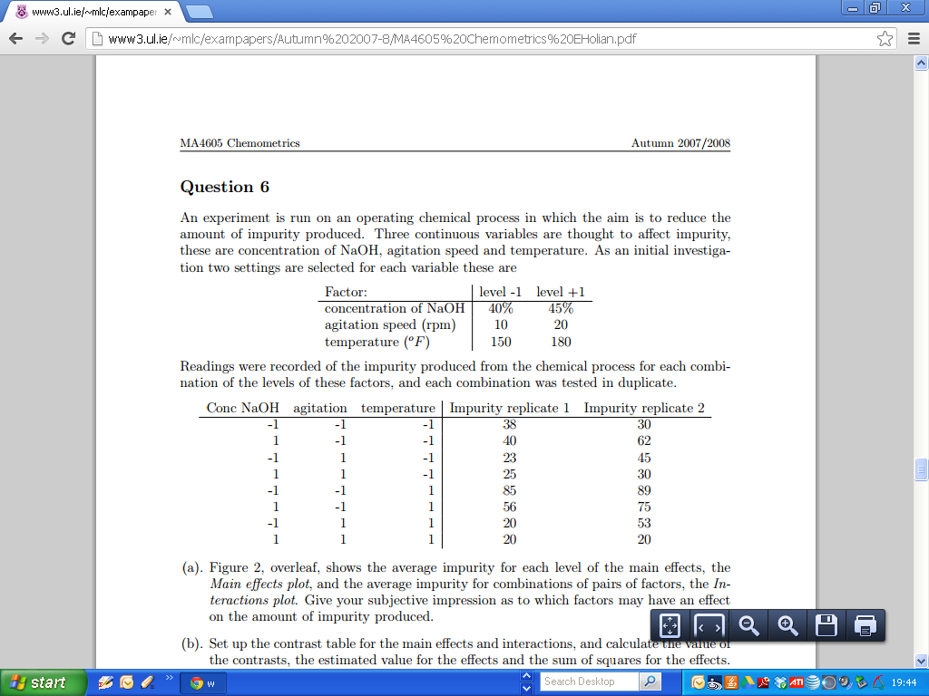

The following information can be presented in the following format.

Notice the first coumn.

|  |  |  |  |  |  |  |
| --- | --- | --- | --- | --- | --- | --- |
|  | A | B | C | Repl1 | Repl2 | Total |
| (1) | -1 | -1 | -1 | 38 | 30 | 68 |
| a | 1 | -1 | -1 | 40 | 62 | 102 |
| b | -1 | 1 | -1 | 23 | 45 | 68 |
| ab | 1 | 1 | -1 | 25 | 30 | 55 |
| c | -1 | -1 | 1 | 85 | 89 | 174 |
| ac | 1 | -1 | 1 | 56 | 75 | 131 |
| bc | -1 | 1 | 1 | 20 | 53 | 73 |
| abc | 1 | 1 | 1 | 20 | 20 | 40 |
|  |  |  |  |  |  |  |

This format allows us to compute the contrasts, effects and sums of squares for the main effects and interaction effects.

(For later – we note that the average value of the responses is 44.4375)

The following calculations allow us to construct the ANOVA table.

*The formulae for main effects are not given in the exam*

***Main Effect for Factor A : 23 Design***

|  |  |
| --- | --- |
| ***Main Effect for Factor B : 23 Design*** | |
|  |  |



***Main Effect for Factor C : 23 Design***



The numerator is known as the **Contrast**.

The number of replicate measurements is “n” ( in this example n=2)

Formulae for Interaction Effects will be given in exam paper. (See Exam Shell in Special Classes Folder on SULIS ).

MA4605 Chemometrics 2007/2008



Compute the Contrasts, the Main Effects and Interaction Effects, and the Sums of Squares.

|  |  |  |  |  |  |  |
| --- | --- | --- | --- | --- | --- | --- |
|  | A | B | C | Repl1 | Repl2 | Total |
| (1) | -1 | -1 | -1 | 38 | 30 | 68 |
| a | 1 | -1 | -1 | 40 | 62 | 102 |
| b | -1 | 1 | -1 | 23 | 45 | 68 |
| ab | 1 | 1 | -1 | 25 | 30 | 55 |
| c | -1 | -1 | 1 | 85 | 89 | 174 |
| ac | 1 | -1 | 1 | 56 | 75 | 131 |
| bc | -1 | 1 | 1 | 20 | 53 | 73 |
| abc | 1 | 1 | 1 | 20 | 20 | 40 |
|  |  |  |  |  |  |  |

The contrast for A is the numerator for the main effect. i.e.



Using the sum of the two replicates, the contrast for Factor A is

102 + 55 + 131 + 40 – 68 -68 - 174 – 73 = ***- 55***

The main effect is the contrast divided by 4n i.e. ***-6.875.***

The Sum of Squares is found using the formula.

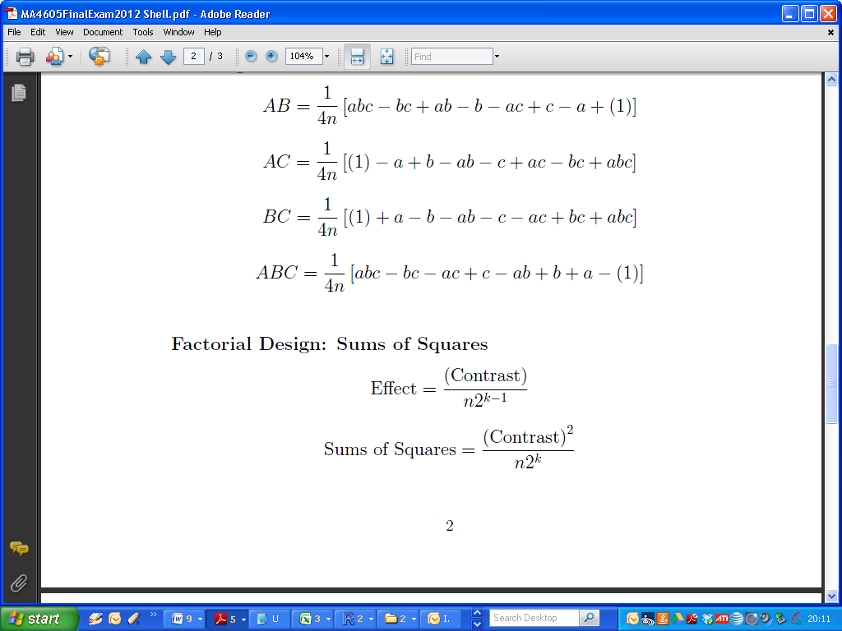

SumSq = $\frac{{(-55)}^{2}}{2 ×2^{3}}=\frac{{(-55)}^{2}}{16}$ = 189.0625

**Main Effect for Factor B**

(Skipped in this document, for sake of brevity. Results are tabulated later)

**Main Effect for Factor C**

The contrast for C is the numerator for the main effect. i.e.



Using the sum of the two replicates, the contrast for Factor A is

174+131+73+40-55-68-102-68 = 125

The main effect is the contrast divided by 4n i.e. ***15.625***

The Sum of Squares is found using the formula.



SumSq = $\frac{{(125)}^{2}}{2 ×2^{3}}=\frac{{(125)}^{2}}{16}$ = 976.5625

**Interaction Effect for Factors A and C**

Using formula ( Given in exam paper)

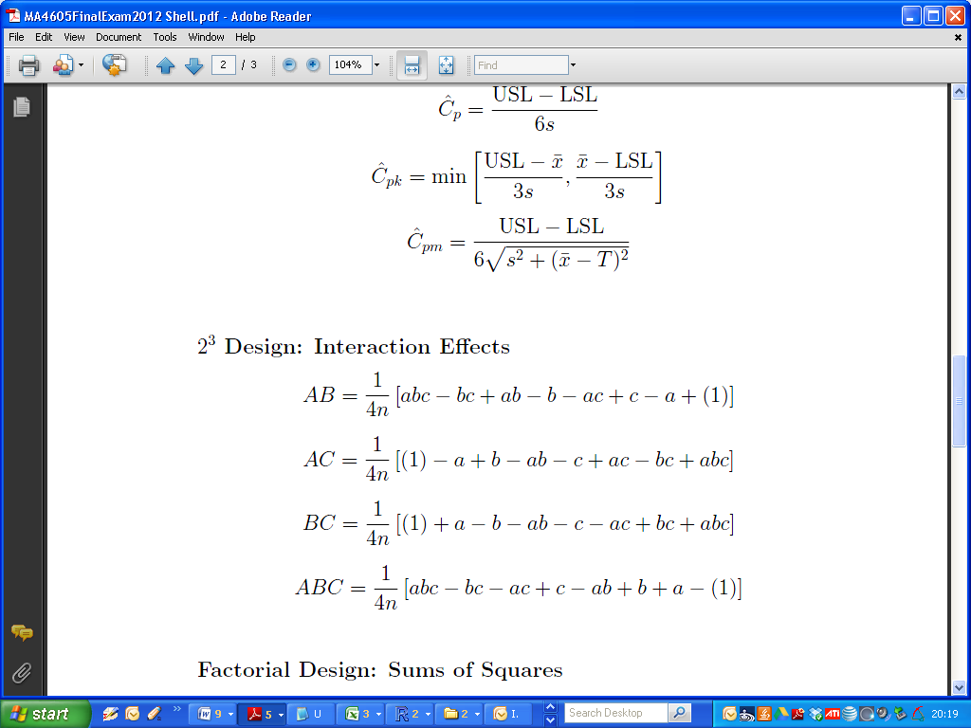

The contrast is computed as follows:

***68-102+68-55-174+131-73+40 = -97***

The full set of results are as follows:

|  |  |  |  |  |  |  |  |  |  |
| --- | --- | --- | --- | --- | --- | --- | --- | --- | --- |
|  | Contrast | | | Effect | |  | Sum SQ | | |
| A | -55 | | | -6.875 | |  | 189.0625 | | |
| B | -239 | | | -29.875 | |  | 3570.063 | | |
| C | 125 | | | 15.625 | |  | 976.5625 | | |
| AB | -37 | | | -4.625 | |  | 85.5625 | | |
| AC | -97 | | | -12.125 | |  | 588.0625 | | |
| BC | -145 | | | -18.125 | |  | 1314.063 | | |
| ABC | 57 | | | 7.125 | |  | 203.0625 | | |
|  | |  |  | |  | | |  |
|  | |  |  | |  | | |  |
|  | |  |  | |  | | |  |
|  | |  |  | |  | | |  |
|  | |  |  | |  | | |  |
|  | |  |  | |  | | |  |
|  | |  |  | |  | | |  |
|  | |  |  | |  | | |  |
|  | |  |  | |  | | |  |

|  |
| --- |
| > summary(Model2)  Df Sum Sq Mean Sq F value Pr(>F)  A 1 189 189 1.199 0.30540  B 1 3570 3570 22.640 0.00143 **  C 1 977 977 6.193 0.03761 *  A:B 1 86 86 0.543 0.48239  A:C 1 588 588 3.729 0.08956 .  B:C 1 1314 1314 8.333 0.02030 *  A:B:C 1 203 203 1.288 0.28932  Residuals 8 1262 158  ---  Signif. codes: 0 ‘***’ 0.001 ‘**’ 0.01 ‘*’ 0.05 ‘.’ 0.1 ‘ ’ 1 |